RMS

Business Requirement Document

Table of Contents
1. Introduction 3
1.1. Document Purpose 3
1.2. Background of Records Management 3
1.3. Purpose of Project 3
1.4. Purpose of the Business Requirements Error! Bookmark not defined.
2. Requirements Scope 4
2.1. In Scope 4
2.2. Out of Scope 4
3. Functional Requirements 4
3.1. Records Management Specification 5
Revision Log 15
Appendices 15
Approval 15

Introduction

Document Purpose

The purpose of this document is to describe business requirements of Records Management System, an application completely, accurately and unambiguously in Technology-independent manner. All attempts have been made in using mostly business terminology and business language while describing the requirements in this document. Very minimal and commonly understood Technical terminology is used. Use case / Designer approach are used in modeling the business requirements in this document.

Background of Records Management

Records management is a process to preserve all loan and mortgage papers of an approved case and related scan images. With aim of preventing the documentation from security risk the life cycle includes:
- Records centralization is the first stage to collect all loan and mortgage documents from the Branches/ Transaction Offices
- Records maintenance and use is the second stage, in comprise of dispatching, packing, storage, retrieval and replication if required.
- Records retention and destruction is the final stage relating to records destruction no longer needed.

Purpose of Project

Purpose of this project is an examination process of Records Management and existing Records Management System (ext_RMS). After reviewing all factors: business process; ext_RMS’s performance, etc. We will deceive to continue developing based on existing RMS or build another RMS from scratch.

Requirements Scope

This section shows what business functionality is in scope and out of scope for Implementation. In Use case approach, the out of scope Use cases are indicated in a separate boundary box. In Oracle Designer approach the out of scope Functions are shown in grey coloured boxes.

In Scope
Most functions, user’s activities in records management process, data processing that application can handle.
- Users interact with RMS:
  - Sale Admin
  - CIU
  - CSC
  - RMT
- General functions supported by RMS
- Update information of Loan list, contract, MRC…
- Following status of documents.
- Printing
- Manage document life’s circle.

Out of Scope

Functional Requirements

This section describes the Functional requirements part of the Business Requirements. In Use case approach, the Functional Requirements comprises of Actor Profile Specification, Essential Use case diagram and Essential Use case specification in narrative text form. In Oracle Designer approach the Functional Requirements comprises of Business Unit Definition Report, Function Hierarchy Diagram and Function Definition Report.

Records Management Specification

    - FLOWCHART – RECORDS MANAGEMENT ACTIVITIES

Loan Agreement / Mortgage documents

CENTRALIZING

CHECKING

DISPATCHING
LOAN AGREEMENT

STORAGE

RETENTION &
DESTRUCTION
Stage 2
Stage 3
Stage 1

* Within two working days from date of loan approval
* Must be put into a red folder of PVFC
* Attached with a Document Receipt Note/Checklist
* Verifying with a checklist on the front side of folder
* Checking “Verified against originals” stamp if loan documents in photocopy
* Checking CST signatures and PVFC ’s authorization
* Printing Welcome Letter
* Photocopy Disbursal Request
* Mailing Loan Agreement to customers
* Checking via scan images and a checklist
* Packing into carton box and sealing for storage
* Moving to the stock of CROWN⁽¹⁾ for storage

RECORDS MANAGEMENT TEAM
BRANCH/ TRS OFFICE

    - FLOWCHART – RECORDS MANAGEMENT FUNCTIONALITIES
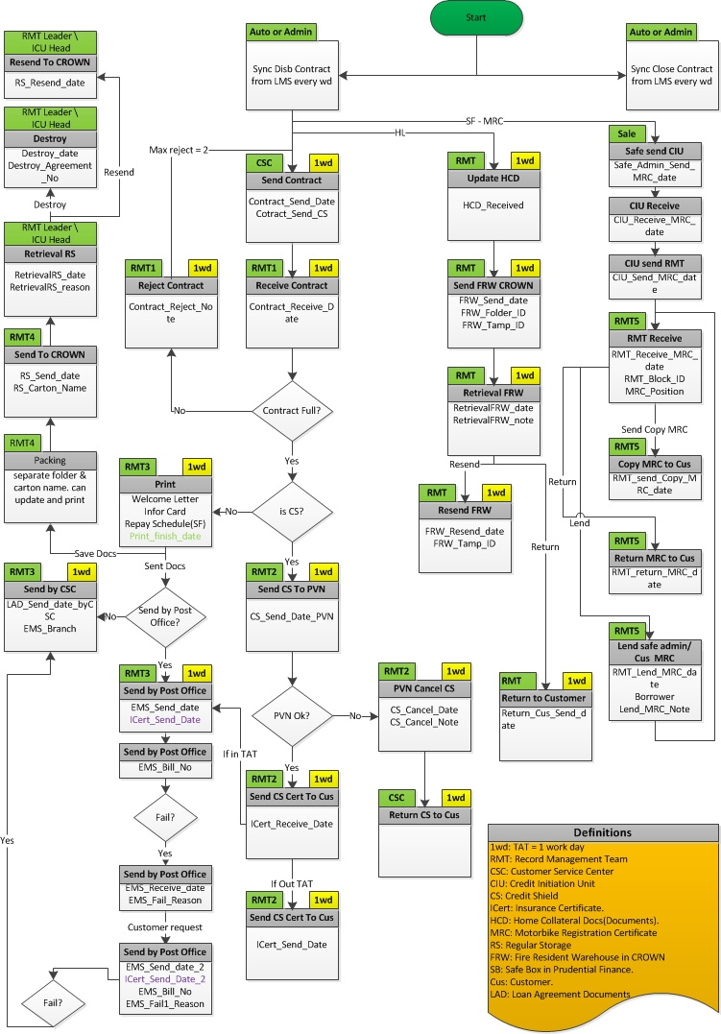
  - Functional blocks and uses case

    - COLLECTING NECESSARY DATA

This phase we need supporting from Database Administrator Team. They provide data that we require for RMT.

    - CSE SUBMIT LOANLIST DOCUMENT

CSE is the main actor in this phase. RMS will provide them a list of disbursed Loan which can be sent to RMT and they can see Loans of their CSC. With this list, they can:
- View.
- Print/Export list for reference.
- With every Loan/ record on the list, CSE can check in fields as “Have CS”, “Send with CS”, or make a note, etc… if necessary.
- Chose Loans which they want to submit/ send to RMT after checking their document. After choosing, CSE clicks “Submit”, then Loans they chosen will be sent to RMT as a list and it’s printable also.

Information requires:
- Loan No/App No
- Send date (auto)
- Loan have CS/ non CS (manual)
- Sending with CS/ without CS (manual)

    - RMT RECEIVE/PROCESS LOANLIST

RMT is the main actor in this phase. We call this actor is RMT1. RMT1 will log on to RMS to see a list of Loans being sent by CSE. RMT1 can:
- Filter by: branch, sent Date/received Date, CS or non-CS, sent with CS or without CS, etc…
- Edit/make a note
- If Loan document has CS, RMT1 must update info of it to RMS.
- Reject Loans to CSE with note if Loan document having problem. CSE will receive a list of Loan rejected by RMT1 on their screen; they must make a supplementation for these rejected Loans. A Loan can be rejected twice by RMT. After third receiving, Loan can’t be rejected again. If there is any problem, RMT1 must contact to CSE directly. This is an outbound-system action.
- Waiting Loans: RMT1 receives the loans from CSE, check & find out some loans are not qualified, which will be marked as waiting loans. Waiting list of loan will be sent to CSE. CSE must follow-up waiting list and complete this transaction by send the necessary documents to RMT. If supplementation is qualified , RMT1 marks as “confirm” on system.
- Finally result of this phase are:
  - A list of Loans’ document accepted by RMT1.
  - A list of CS received by RMT1.
  - A waiting list of RMT
- Print/Export list for reference.

- TAT for all processes of a Loan begins calculating when RMS update list of Loan submitted by CSE for RMT1, and TAT is 1 working day.
- TAT for waiting list is 2 working days

Information requires:
- For CS
  - Loan No/ App No (manual)
  - Receive date (auto)
  - Date of sending to PVN (auto)
  - CS info: CS No or something else (manual)

- For Loan document
  - CSE/CSC submit (auto)
  - Receive date (auto)
  - Loan have CS/ non CS (auto)
  - Sending with CS/ without CS (auto)
  - Number of receiving (auto)
  - Number of rejection (auto)
  - Reason of rejection (manual)

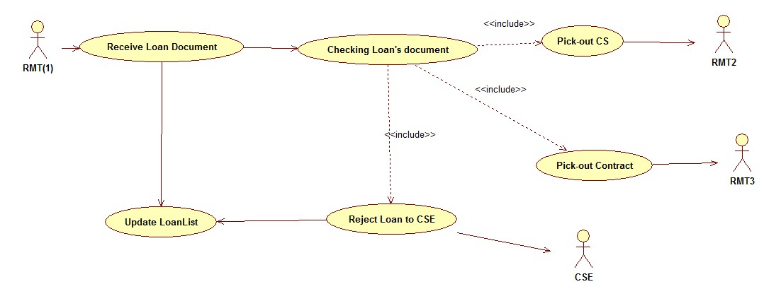

    - RMT PROCESS CONTRACTS DOCUMENT

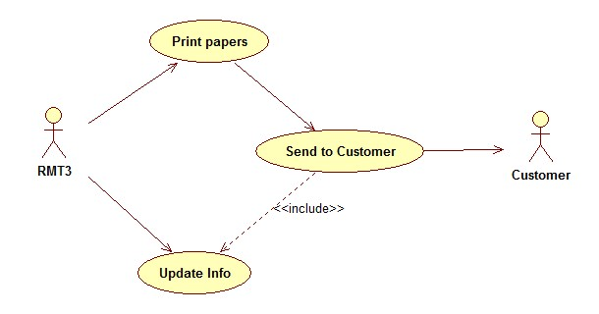
RMT3 is the main actor. RMT3 will have a list of Loans’ document on screen. Based on this list, RMT3 must be print Welcome letter, Info Card, Repay Schedule... followed rules of Records Management process. RMS supporting user to issue, print necessary papers from templates.

After finish printing, RMT3 send these papers to Customer. This process may be loops twice. First, RMT3 will send to mailing address of Customer, the Date, Billing no must be updated to RMS. Second, reasons of the first failure must be updated to RMS. At last, Customer must receive these papers directly at PVFC’s branch/ office.

Information requires:
- Sent date (auto)
- Sent to whom (manual)
- Sent what (manual)
- Number of sending (auto)
- Post-office’s billing no
- Reason of previous return (manual)

    - RMT PROCESS CREDIT SHIELD

RMT2 receives CS from step “RECEIVE/PROCESS LOANLIST”. After update required info to RMS, CS will be sent to PVN. There are some cases of result:
- PVN accept CS
- PVN reject CS (some supplementary details of CS are required), CS will be returned to RMT. RMT must contact with Customer to make supplementation.
- PVN deny CS (CS is abandoned). RMT must inform to Customers that their CS is abandoned.

PVN must updated information of CS to RMS.
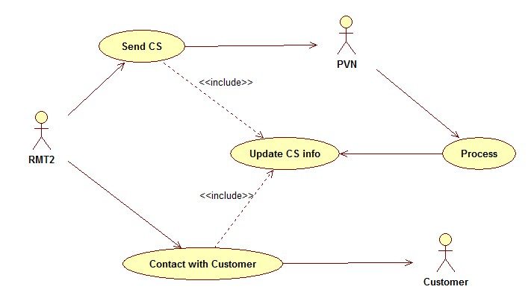
Information requires:
- Send date (auto)
- CS No (manual)
- Number of sending (auto)
- CS state (auto)
- Reject note (manual)
- Abandon note (manual)

    - RMT PROCESS HOMELOAN’S DOCUMENT

HomeLoan’s Document is a collection of mortgages. This step has two sub-processes.

- Package document and send to CROWN
RMT will collect required documents and put them into files, stamped with Seal and Barcode provided by CROWN. Seal-code and Bar-code must be update to RMS.

- Retrieve document and re-storage
Documents storing at CROWN can be retrieved based on Seal-code and Bar-code. If re-storage is necessary, new Seal-code and Bar-code must be updated to RMS

Information required:

- App No/Loan No
- Date of sending to CROWN
- Seal-code, Bar-code
- Retrieve date
- Reason of retrieving
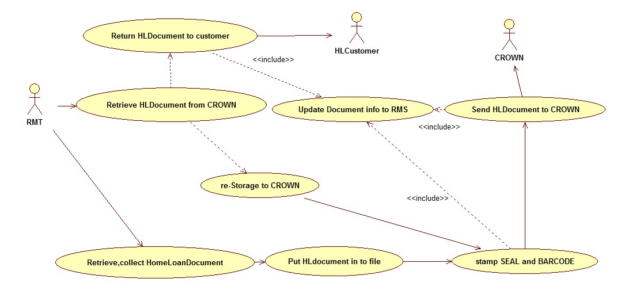
- Date of return to Customer
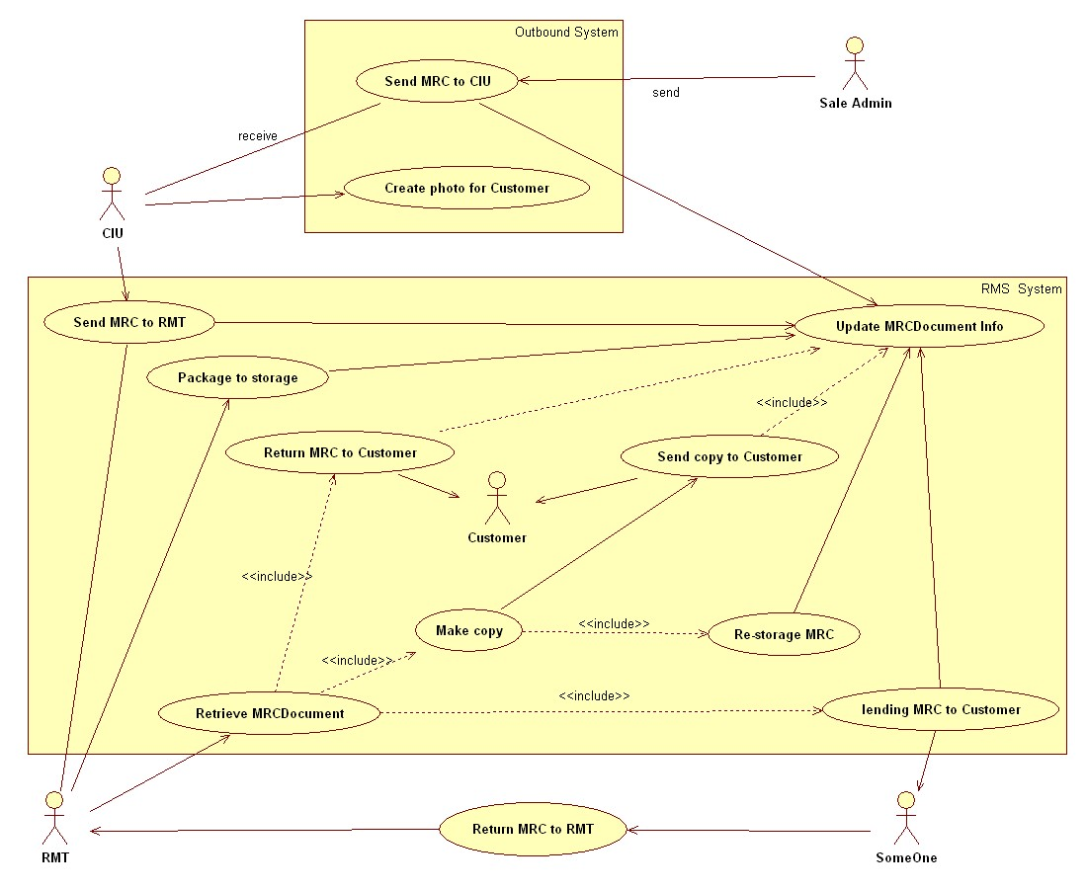
    - RMT PROCESS MRC’S DOCUMENT
When CIU receive a batch of MRCs from Sale Admin, they must update information to a list on RMS.
Information requires:
- Receive date
- First copy issue date
- Information about every MRC

After making copies for MRCs, CIU send them to RMT. RMT must update information of MRCs they receive.

There are many activities of MRC processing in RMT
- Storage
RMT storage MRCs by batch with following rules:
- All of MRCs have the same First-copy Date will be put in a package named is First-copy Date.
- All of MRCs in a package will be divided into block (group A, B, C…).
- Every block is a stack that every MRC has an index for manage. MRC’s index will be updated if the quantity of MRC changed.
Information requires:
- MRC’s position: package, block, index
- First copy issue date
- Information about every MRC

- Retrieve – Re-storage
Information requires:
- MRC’s position: package, block, index
- Information about every MRC

- Make MRC’s copy
Information requires:
- MRC’s position: package, block, index
- Make-copy Date
- Information about every MRC

- Lending – Re-storage
MRC’s index, reasons for MRC’s lending, who borrowed… must be updated.
Information requires:
- MRC’s position: package, block, index
- Lending info
- Information about every MRC

  - RMS Sequence Reference

RMS Update

RMS update required? Yes No
RMS updated/to be updated on (date):

Comments:

Revision Log

Date | Version | Change Reference | Reviewed by
[date]

Appendices

Approval
This document has been approved as the official Business Requirements Document for the RMS project.
Following approval of this document, changes will be governed by the project’s change management process, including impact analysis, appropriate reviews and approvals, under the general control of the Master Project Plan and according to Project Support Office policy.
Prepared by | Signature | Date
Vo My Phuong
Assistant Manager, O&T
Reviewed by | Signature | Date
Ngo Ngoc Nga
Head of Operations

Approved by | Signature | Date
Luu Ngoc Diep
Head of O&T

